**SAT / ACT Prep Online Guides and Tips**

[**What's Actually Tested on ACT Math section? Concepts, Subjects, and Skills**](https://blog.prepscholar.com/whats-tested-on-act-math-concepts-subjects-and-skills)

https://blog.prepscholar.com/hs-fs/hub/360031/file-2392391327-png/author_halle.png?t=1515302302196&width=45&name=author_halle.pngPosted by [Halle Edwards](https://blog.prepscholar.com/author/halle-edwards) | May 14, 2015 5:30:00 PM [ACT GENERAL INFO](https://blog.prepscholar.com/topic/act-general-info)

Preparing for the ACT? You’re probably wondering what you need to know to be ready for the math section. For many students, this can be the most stressful part of the ACT because of its breadth and time difficulty.

In this post, we'll break down exactly what will appear on the ACT math test, with example questions. We will also give you the resources you need to start studying so you can get the best score possible.

**ACT Math Section Format**

The ACT math section is 60 minutes long, with 60 questions total – **so you’ll have just one minute to complete each question.** You’ll definitely have to work quickly if you want to answer each one! Every question is multiple choice, and there is no penalty for guessing.

Pacing and problem solving are the big challenges on the ACT math section.**Pacing is tricky because you have to try to as many questions as possible without losing accuracy.** In addition, you have to be able to quickly identify ways to solve problems. This is why studying specifically for ACT math is so important, since it requires you to work faster and more strategically than you have to in math class.

You need to be able to problem-solve, or use what the ACT calls using reasoning abilities. **In addition**, **the questions are not ordered by topic, so you need to be prepared to quickly switch between topics** like statistics, algebra, and geometry.

**Test Content and Requirements**

The ACT tests math skills typically taken by all students by the beginning of grade 12 – which in practice means nothing beyond Algebra II. If you’re an advanced student, ACT math content will be very straightforward.

**The content breakdown for ACT math is Pre-Algebra (20-25%), Elementary Algebra (15-20%), Intermediate Algebra (15-20%), Coordinate Geometry (15-20%), Plane Geometry (20-25%), and Trigonometry (5-10%).** We’ll explore those sections in-depth with example problems, and explain how you get scores for each section.

You can use a calculator – [but it has to be a permitted one](http://www.actstudent.org/faq/calculator.html). **But you’re not required to use a calculator, meaning all problems on the ACT can be solved without one.** Be careful not to rely too much on your calculator if you use one, as it can actually slow you down. (For an expert discussion on [the best calculators for standardized tests, see our post](https://blog.prepscholar.com/calculators-on-the-sat-tips-from-experts).)

Unlike the SAT, **you’re not given a reference sheet,** so you have to know basic math formulas (y = mx + b, the area formula, the quadratic formula, etc) but nothing too complex.

**ACT Math Section Subscores**

Your score is based on how many total points out of 60 possible you earn. That raw score is converted to a section score between 1 and 36 (for more on that process, [see our ACT scoring guide](https://blog.prepscholar.com/how-is-the-act-scored)).

**You also receive three subscores based on the six content areas**: pre-algebra and elementary algebra, intermediate algebra and coordinate geometry, and plane geometry and trigonometry. The subscores basically give more detailed information about your performance, but are generally not looked at too closely by colleges (your overall math section score and ACT composite are most important).

However, **you can use the subscore areas to focus your studying by math topic.** We will explore the three math subsections and show some example questions for each. You might find that you are more than prepared for one area but need to focus your practice on one topic, like trigonometry or coordinate geometry.

While we will give a detailed overview of what you can expect to see on the math section, we also recommend doing full practice tests so you can really get a sense of what the ACT math section is really like.

**1. Pre-Algebra/Elementary Algebra**

**Pre-Algebra (20-25%)**

* Basic operations using whole numbers, decimals, fractions, and integers
* Place value
* Square roots and approximations
* The concept of exponents
* Scientific notation
* Factors
* Ratio, proportion, and percent
* Linear equations in one variable
* Absolute value and ordering numbers by value
* Elementary counting techniques and simple probability
* Data collection, representation, and interpretation
* Understanding simple descriptive statistics

**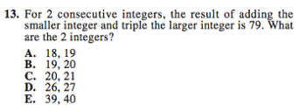***A basic operations problem.*

**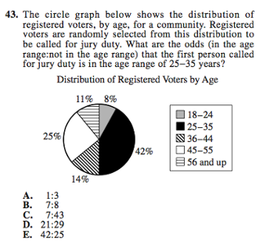***A probability problem based on a real-  
 world situation.*

**Elementary Algebra (15-20%)**

* Properties of exponents and square roots
* Evaluation of algebraic expressions through substitution
* Using variables to express functional relationships
* Understanding algebraic operations
* The solution of quadratic equations by factoring

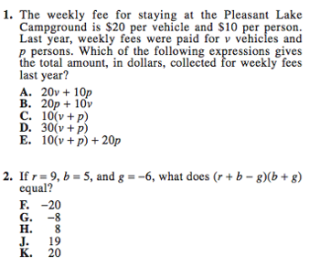

*Two elementary algebra problems. The first uses variables to express a real-world relationship. The second tests evaluation of algebraic expressions through substitution.*

**2. Intermediate Algebra/Coordinate Geometry**

**Intermediate Algebra (15-20%)**

* The quadratic formula
* Rational and radical expressions
* Absolute value equations and inequalities
* Sequences and patterns
* Systems of equations
* Quadratic inequalities
* Functions and modeling
* Matrices
* Roots of polynomials
* Complex numbers

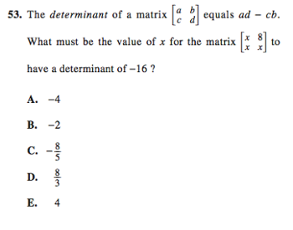

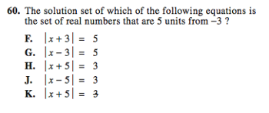

**Coordinate Geometry (15-20%)**

* Graphing and the relations between equations and graphs, including points, lines, polynomials, circles, and other curves
* Graphing inequalities
* Slope
* Parallel and perpendicular lines
* Distance
* Midpoints
* Conics

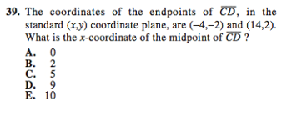

**3. Plane Geometry/Trigonometry**

**Plane Geometry (20-25%)**

* Properties and relations of plane figures, including angles and relations among perpendicular and parallel lines
* Properties of circles, triangles, rectangles, parallelograms, and trapezoids
* Transformations
* The concept of proof and proof techniques
* Volume
* Applications of geometry to three dimensions

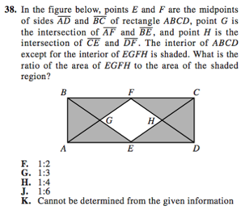

**Trigonometry (5-10%)**

* Trigonometric relations in right triangles
* Values and properties of trigonometric functions
* Graphing trigonometric functions
* Modeling using trigonometric functions
* Use of trigonometric identities
* Solving trigonometric equations

**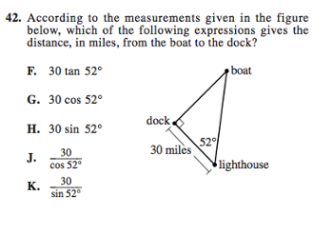***Example questions via*[*Preparing for the ACT*](http://www.act.org/aap/pdf/Preparing-for-the-ACT.pdf)*.*

**What’s Next?**

Now that you know what’s on the ACT Math section, why not try a practice test? See [our links to free, official online practice tests](https://blog.prepscholar.com/complete-official-act-practice-tests-free-links) to get started.

Not sure what your target ACT score should be? [Learn what a good, bad, or excellent score looks like](https://blog.prepscholar.com/what-is-a-good-act-score-a-bad-act-score-an-excellent-act-score), and the type of score you should aim for based on your dream colleges.

Want to study with a prep book? See our guide to [the best ACT prep books on the market](https://blog.prepscholar.com/best-act-prep-books-2015).

Want some help studying? [Consider using our PrepScholar program](https://www.prepscholar.com/act/s/). We take the hard part out of studying so you can focus on practicing for the test, using high-quality practice questions, and improving your weak areas.

Are you not a big fan of geometry? [See if it’s possible to take the ACT without geometry](https://blog.prepscholar.com/can-you-take-the-act-without-geometry).

Looking for a perfect ACT math score? [Get tips from our 36 full-scorer](https://blog.prepscholar.com/how-to-get-36-on-act-math-8-strategies-by-a-perfect-scorer).